|  |  |  |  |  |  |  |
| --- | --- | --- | --- | --- | --- | --- |
|  | a | b | c | d | e | f |
| a | 0 | 3 | 0 | 4 | 0 | 5 |
| b | 0 | 0 | 1 | 0 | 0 | 1 |
| c | 0 | 0 | 0 | 2 | 0 | 0 |
| d | 0 | 3 | 0 | 0 | 4 | 0 |
| e | 0 | 0 | 0 | 3 | 0 | 2 |
| f | 0 | 0 | 0 | 2 | 0 | 0 |

**(3) a)**

**b)**

a: 🡪 b,3: 🡪 d,4: 🡪 f,5: nil

b: 🡪c, 1: 🡪 f,1: nil

c: 🡪 d, 2: nil

d: 🡪 b,3: 🡪 e,4: nil

e: 🡪 d, 3: 🡪 f,2: nil

f: 🡪 d,2: nil

**(4) a)**

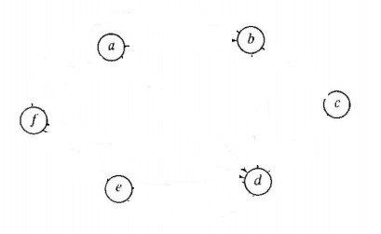

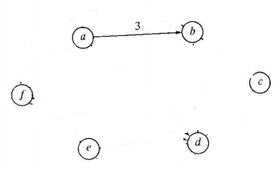

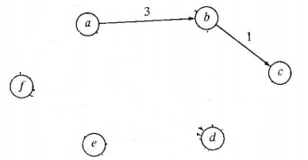

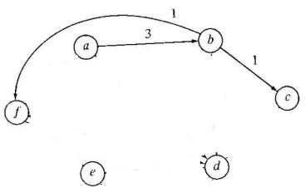

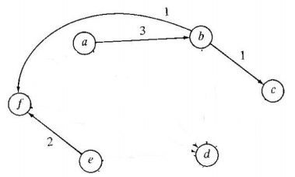

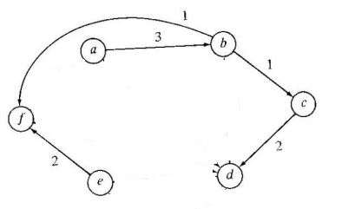

Cost = 9

**b)**

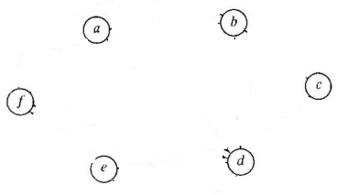

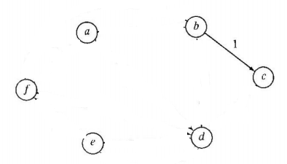

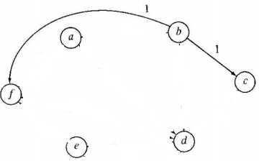

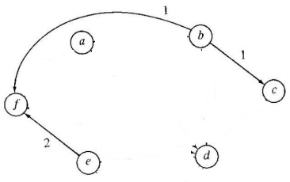

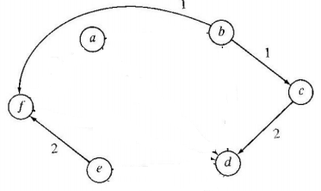

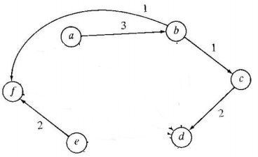

**Cost = 9**

|  |  |  |  |  |  |  |
| --- | --- | --- | --- | --- | --- | --- |
|  | a | b | c | d | e | f |
| a | 0 | 1 | 1 | 1 | 1 | 1 |
| b | 0 | 1 | 1 | 1 | 1 | 1 |
| c | 0 | 1 | 1 | 1 | 1 | 1 |
| d | 0 | 1 | 1 | 1 | 1 | 1 |
| e | 0 | 1 | 1 | 1 | 1 | 1 |
| f | 0 | 1 | 1 | 1 | 1 | 1 |

**5)**